Managing BCD’s WebSmart PHP
With
Aldon ALM Solutions

Last updated: April 21, 2009

Managing BCD’s WebSmart PHP 1
Prolog 2
What is BCD’s WebSmart PHP? 2
What is Aldon’s Application Lifecycle Management Solution 2
Part I: Overview 3
How are the Products Working Together? 3
How is Aldon Managing the Process? 3
How is Aldon Managing Deployment? 4
Part II: WebSmart PHP Setup 6
i5_Connect: Setting up for RLA Templates 6
i5_Connect: Setting up IBM i library list objects 6
Db2_Connect: Setting up SQL access 7
Db2_Connect: Changing the SQL statements to use the new variable 8
Part III: HTTP Server Setup 10
Part IV: Lifecycle Manager Setup 12
LM Setup for Directory-based Artifacts 12
Release Configuration 12
LM Setup for IDE Projects 13
LM Setup for Developer Environments 13
Create the Name Path: 14
Create the Development Environment: 14
DM Setup for Directory-based Artifacts 16

Prolog
This document has been created as assistance to someone desiring to manage BCD’s WebSmart PHP with Aldon’s ALM solution. The guide is not meant to be an exhaustive step-by-step roadmap; a great degree of knowledge of both products is assumed. The reader is strongly encouraged to consult the Technical Support teams at both Aldon and BCD for additional assistance.

Aldon Computer Group makes no warranty, express or implied, with regard to this material, including fitness for use. Additionally, Aldon is not responsible for maintaining compatibility of this information with future releases of either Aldon’s or BCD’s solutions. Aldon provides this as an example only. Customers using this information do so at their own risk.

What is BCD’s WebSmart PHP?
WebSmart PHP is used to create PHP applications that run on the System i and other PHP supported platforms such as Windows, Linux and Unix. It is the most productive tool for PDP or PHP programmers to create PHP applications. WebSmart PHP is more than just an IDE and editor, it is a rapid application development tool that generates nonproprietary PHP code using existing databases in DB2 on the IBM i or MySQL.

What is Aldon’s Application Lifecycle Management Solution
Aldon is a leading ALM vendor with many years of experience providing best-practice ALM solutions to companies both small and large. The solution is comprised of three main tools:
- Community Manager: Provides project and issue management for those requests requiring changes to your software applications
- Lifecycle Manager: Provides a central inventory of every artifact that comprises any software application across your enterprise, regardless of platform. With all of your artifacts centrally stored, LM then provides solid workflow management to the changes that are occurring to your applications on a daily basis. This workflow includes, for example, check out, check in, promote, deploy, get latest, archive, history, compare, emergency processing and much more.
- Deployment Manager: Managing the central inventory is an essential part of the ALM process, but this is not where your live applications are being served. It is the job of Deployment Manager to get the right part to the right locations in a highly automated fashion that is, at the same time, reliable and auditable. DM also provides functionality for speedy rollbacks if something is applied that was not desired.

Part I: Overview

How are the Products Working Together?
WebSmart’s PHP uses a program definition file with an extension of .phw. Once the developer has made the desired changes to the PHW, he/she clicks the “generate” button. Based on the PHW, WebSmart generates the pdp source in the target IFS directory on the IBM i. The WebSmart HTTP server is programmed to server the web pages directly from the php in this address.

As the primary driver of the entire application, solid management of the PHW is essential. Aldon’s Lifecycle Manager will keep all PHW’s stored in its central inventory. Programmers will use LM to quickly locate and checkout the PHW they want to alter. They will also check out the corresponding PDP source/object of the same name.

Once checked out, they will simply double click on the PHW from the LM interface to open WebSmart’s IDE on that item. They will make their changes and then generate the corresponding PDP source. At this point, they simply return back to LM to check in the PHW and the PDP, promote it on through to production and (optionally) deploy it to other partitions/machines.

How is Aldon Managing the Process?
All of the necessary artifacts that drive the WebSmart application will be stored in LM’s central inventory. This certainly means the PHW and the generated PDP source and object. However, it also means the entire DB2 database, other IBM i programs, CSS, HTML, XML, word documents, gif’s, jpg’s and anything else that is critical to the functionality of the application.

Aldon highly recommends that all development activity be task-centered. This certainly helps developers be more organized and focused. The benefits, however, extend far beyond just the developers. The task helps document the changes, closely associating the objects changed with the task that drove those changes. This is extremely useful when QA testing is done. Once QA testing is accomplished, the promotion to production is made much easier if it is done by task, ensuring all the necessary changes, on all platforms, are taken into live production together. After promotion, the task remains in LM’s history forever as an on-going documentation of past changes. This is very important for those companies who have to prove audit compliance. It is also extremely useful during emergency situation where fast access to complete documentation of the offending objects is essential.

Once the task is created, checkout of the desired artifacts may commence. The objects are selected from LM’s central inventory panel and a single click processes the checkout request. Note that both the PHW and the associated PDP artifacts must be checked out. This is because the developer will eventually be overlaying this PDP source and promoting it back up. Aldon automatically marks the objects as checked out and records this information in the history log. The directory-based artifacts (e.g. the PHW) are copied out of the inventory and down to the programming workspace (typically the programmer’s C drive).

Development now happens within the WebSmart IDE. Once all changes are made to the PHW, the developer will click the “generate” button and this instructs WebSmart to generate the PDP source onto the specified IFS directory on the IBM i. If the unit testing is successful, the objects are ready to be checked back in via LM.

What happens next depends on how many environments are defined in LM between development and production. Aldon certainly recommends at least having one environment for Quality Assurance testing. When the developer does a check in of the PHW and the PDP, LM moves the PHW and the PDP source from the developer’s workspace to the QA environment defined to LM.

This means that the PHW and the PDP is copied into LM’s repository. Depending on the settings in LM, the code in the developer’s workspace is either deleted, or kept there but set to “read only”. Note that artifacts in LM’s repository cannot be accessed outside of LM. If you wish to change them, you need to check them out. If you wish to execute them, you must deploy them to another location, e.g. your QA IFS directory. We’ll talk more on deployment next.

How is Aldon Managing Deployment?
Upon check in, the PHW and PDP are returned to the QA environment of the LM inventory. To get something into QA for testing, however, we need to deploy the PDP to the QA directory in the IFS. To accomplish this, Aldon recommends using the Aldon Deployment Manager. DM will take the objects being promoted (at any environment), save them, send them to the target machine(s), receive them and install them into the proper target directory. If your target is on a separate machine or lpar, you will need to purchase a DM client for that machine. If you are also changing supporting artifacts such as CSS or HTML, these artifacts must also be deployed.

Using the DM client gives you additional benefits in the following areas:
- Scheduling
- Separation of duties
- Rollback
- Ease of use

Note that the PHW does not need to be deployed as it does not drive the actual application. Its final resting place is the production environment in the LM inventory, waiting for the next checkout request.

Part II: WebSmart PHP Setup

i5_Connect: Setting up for RLA Templates
If you are using an i5 connect (RLA type templates) you can add this code to the top of your program to detect what your path is and set your library list accordingly.

require('/esdi/websmart/v7.2/include/xl_functions001.php ');
global $i5conn;

// Connect to the database
if (!($i5conn = xl_i5_connect()))
die('Unable to get an i5 connection');

//get url and compare path
$path = getenv('REQUEST_URI');
$pathArray = split('/',$path);

//Set the $libl variable with the correct library name based on the
//the path currently in use in the URL.These values are set in the
//xl_user_preferences.php file (LIVE_PATH = /live) and (TEST_PATH = /test)
switch ($pathArray[1])
{
case LIVE_PATH:
$libl = "BCDILEPDN1";
break;
case TEST_PATH:
$libl = "BCDILEQUA1";
break;
default:
$libl = "XL_WEBDEMO";
}

// Set the default library list
if (!xl_set_libl($libl))
die('Library List not set!');

i5_Connect: Setting up IBM i library list objects
In order for the code above to work properly, there needs to be a special library list object defined in WebSmart on the target machine. This is accessed via the EWRKLIBL command found in the XL_WEBLIB library. When you run this command, you will see a screen that looks something like this:

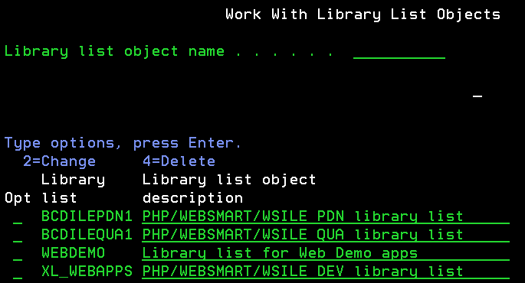

You will set up a WebSmart library list object for each environment that WebSmart is using on this machine. In my demo application, I have one for development (XL_WEBAPPS), QA (BCDILEQUA1) and Production (BCDILEPDN1). As you can surmise, these names match the targets of my LM release environments and DM deployment target libraries.

Inside each of these library list objects is a list of the actual libraries that must be in the library list at run time for WebSmart to function properly at this level. Remember that we are working with a Web application here, and each environment must have a full complement of database files. The QA library list should only specify QA libraries and no production libraries, for example.

More information on creating and maintaining these library list objects can be found in the WebSmart ILE Reference Guide.

Db2_Connect: Setting up SQL access
If you are using a db2connection (SQL on DB2 or MySQL), add this code to set your main library. DB2 connections do not use library lists so you will have to explicitly declare any libraries you want to use.

Replace these lines (toward the very top of the code):
// DB Connection code
require('/esdi/websmart/v7.2/include/xl_functions001.php');
$options = array('i5_naming' => DB2_I5_NAMING_ON);
global $db2conn;
$db2conn = xl_db2_connect($options);

With these lines:
// DB Connection code
require('/esdi/websmart/v7.2/include/xl_functions001.php ');
global $db2conn, $path;

// Determine which path we are running in, live or test
$path = getenv('REQUEST_URI');
$pathArray = split('/',$path);

//Set the $db2lib variable with the correct library name based on the
//the path currently in use in the URL.These values are set in the
//xl_user_preferences.php file (LIVE_PATH = /live) and (TEST_PATH = /test)
//If you have files in other libraries you can put them into
//variables here and use these variable to fully qualify your files, e.g.
//$db2lib2 = "someotherlib";
switch ($pathArray[1])
{
case LIVE_PATH:
$db2lib = "BCDILEPDN1";
break;
case TEST_PATH:
$db2lib = "BCDILEQUA1";
break;
default:
$db2lib = "XL_WEBDEMO";
}
//set your main library here before the connection is made
$options = array('i5_naming' => DB2_I5_NAMING_ON, 'i5_lib' => $db2lib);
$db2conn = xl_db2_connect($options);

Db2_Connect: Changing the SQL statements to use the new variable
Now that we have set the name of the proper DB2 library in the variable, we need to change our code to reference the variable for the library name instead of any current hard-coded library names. Make sure to change any SQL statement to use $db2lib instead of the hard-coded library.
Also note that you may have to change the single quote around the select or update string to a double quote when you insert a variable name into the string.

For example:
$ww_selstring = 'SELECT RRN(MU_CUSTF), MU_CUSTF.CMNAME, MU_CUSTF.CMCUST FROM XL_WEBDEMO/MU_CUSTF';

Becomes:
$ww_selstring = “SELECT RRN(MU_CUSTF), MU_CUSTF.CMNAME, MU_CUSTF.CMCUST FROM $db2lib/MU_CUSTF”;

And:
$result = db2_exec($db2conn, 'delete from XL_WEBDEMO/MU_CUSTF where rrn(MU_CUSTF)= ' . $ww_rrn);

Becomes:
$result = db2_exec($db2conn, "delete from $db2lib/MU_CUSTF where rrn(MU_CUSTF)= " . $ww_rrn);

Part III: HTTP Server Setup

Now we need to teach the WebSmart server to recognize the “test” and “live” directories that we created above. We do this by configuring the “proxypass” settings in the HTTP config file.

WebSmart runs natively on the IBM i via the HTTP Apache Tomcat server. On each IBM i, you should see the QHTTPSVR subsystem running and at least the ADMIN and WEBSMART jobs running underneath that. If you are not seeing these, try running the STRTCPSVR SERVER(*HTTP) HTTPSVR(*ALL) command.

Once you see these jobs running, you can manage the servers on that box via the web address: http://172.25.9.104:2001/HTTPAdmin where 172.24.9.104 is the IP address of my production IBM i.
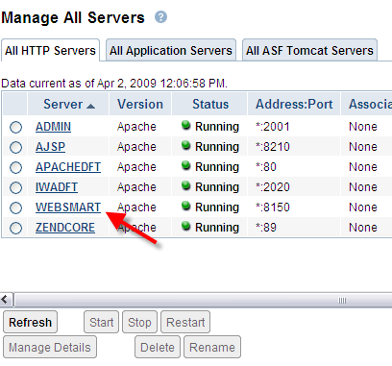

Paste this code into the config file:

# -------------------------------------------
# Directives for WebSmart PHP QA testing
#
ProxyPass /test/ http://127.0.0.1:8000/test/
ProxyPassReverse /test/ http://127.0.0.1:8000/test/

# -------------------------------------------
# Directives for WebSmart PHP live production
#
ProxyPass /live/ http://127.0.0.1:8000/live/
ProxyPassReverse /live/ http://127.0.0.1:8000/live/

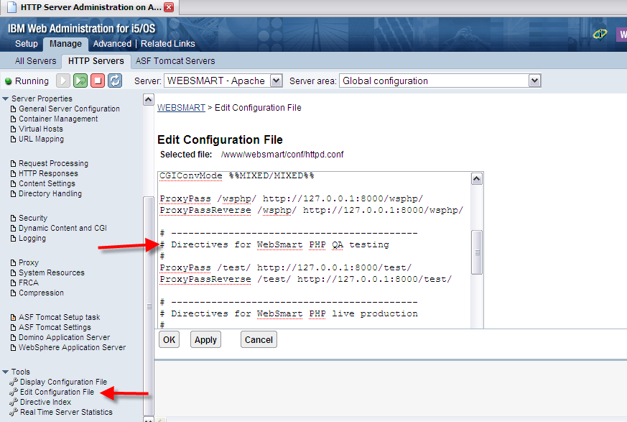

Part IV: Lifecycle Manager Setup

LM Setup for Directory-based Artifacts
For the same reasons that we needed an LM release structure to manage the library-based components of our WebSmart application, you will also need an LM release structure to manage the directory-based components. In fact, since the PHW is the source of the eventual PDP that drives the application, managing the PHW is essential. As mentioned before, many companies choose to extend WebSmart ILE with their own css, html, xml, gif and jpg artifacts. If these artifacts are a part of the final web application, they definitely should be managed by an LM release.

You will create an LM release to maintain each of your unique WebSmart applications. You may name your group/application/release anything that helps you better organize your inventory. For example, I created a group/application/release called PHP/WebSmart/PHP 2.20. You can have as many environments in between Dev and Production, as you wish. Aldon highly recommends that you at least have one for QA. For reference sake, I defined three environments in my application, Dev, QA and Production.

Release Configuration
The LM release definition is pretty much standard issue. There is no native IBM i components to be managed in this release. Remember to force a deployment when promoting to all environments.

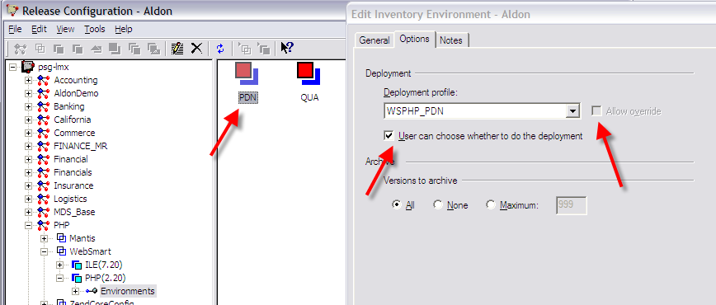

LM Setup for IDE Projects
We need to create two IDE projects for LM to manage. One will handle only the PHW artifacts and the other will manage everything else. We want two separate projects to give LM the ability to manage these two types of artifacts differently. For example, we never want to deploy the PHW’s. Additionally, the artifacts are developed and promoted to different target directory structures.

The following screen shot illustrates creating the PHW project.

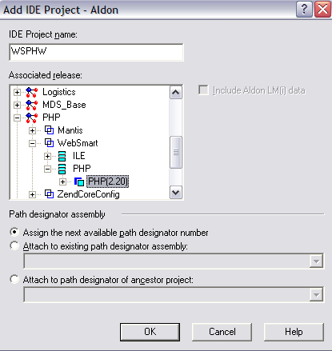

LM Setup for Developer Environments
The developer will be using the WebSmart IDE to work on his/her PDW code and generate the initial PDP code. The IDE is configured, by default, to store the PDW code in

NOTE: If you are running LM on a Linux server, you have two choices.
- Use WebSmart’s FTP Sites tool to send the generated PHP to a development location on the Linux server (e.g. /home/WebSmartPHP/www/zendcore/htdocs/wsphp/). Define your Development Environment to checkout to and promote from this location. The advantage to this design is that you don’t have to mess with starting NFS daemons and mounting foreign drives. The disadvantage is that the HTTP server is running on the 400 and can’t serve PHP from a Linux location, so you can’t do automated unit testing of your web page. However, you can easily create a second FTP site in the IDE that does populate the IFS and regenerate the code there for unit testing.
- Use WebSmart’s FTP Sites tool to generate the PHP code to the IBM i IFS. In order for LM on the Linux box to “see” this location for check out and promote, you will either need to create a target directory structure on the Linux server, mount that directory to the i via the NFS and create an “export” or connection between the two servers. The advantage to this choice is that when you are in the WebSmart IDE and click on your initial “generate and load”, you will be able to instantly see your changed web page while still in development.

Create the Name Path:
Setup/External Setup/Paths. This is creates a global path to the root directory structure where the PHP code will be stored on the server. It will be defined once and used many times in the developer profiles configured next.
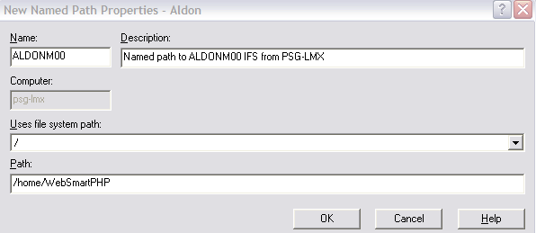

Create the Development Environment:
Setup/External Setup/Environments/Development. Each developer should have his/her own development environment(s) defined.

Server-based:
By default, WebSmart PHP generates the PHP and FTP’s it back to the IFS directory structure on the IBM i. For LM to check out to and promote from this directory, we need to define a development environment that is server-based instead of client-based (developed on your C drive).

Create a new server-based development environment as follows:
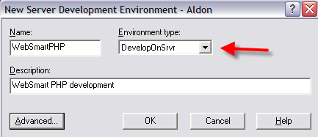

Once you have the environment created, RC on it and select “Environment Paths”. Choose the Server Paths tab and select New.
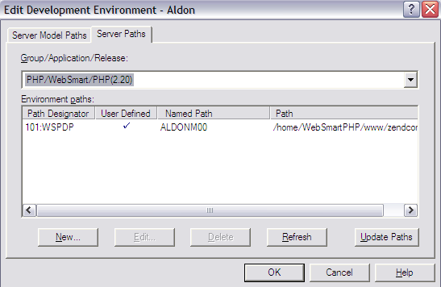

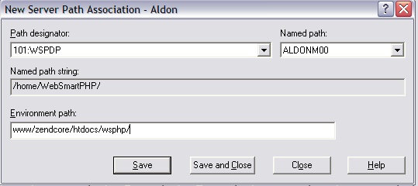

DM Setup for Directory-based Artifacts
Because WebSmart PHP is a directory based application, we need to deploy the changed artifacts to a directory-based server target. In most cases, this is the IFS of the IBM i, but you can certainly configure Deployment Manager to deploy and install on any target server that WebSmart supports. To accomplish this deployment, you will need the DM client that is capable of deploying to directories, not libraries. Please contact Aldon if you do not have this client.

To accomplish this deployment, you will need to configure a deployment profile for each target directory, e.g. one for production and one for QA (if you have a QA web server). The profile for a QA deployment to “test” is illustrated below.

Deployment Profile:
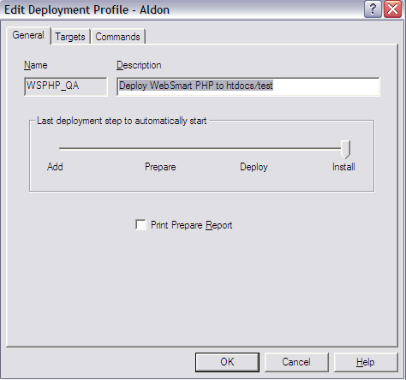

Deployment Target:
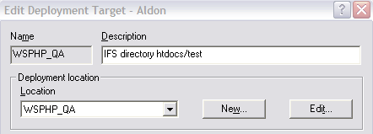

Deployment Location/General:
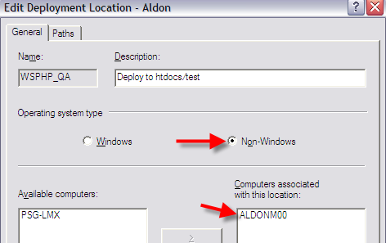

Deployment Location/Paths:
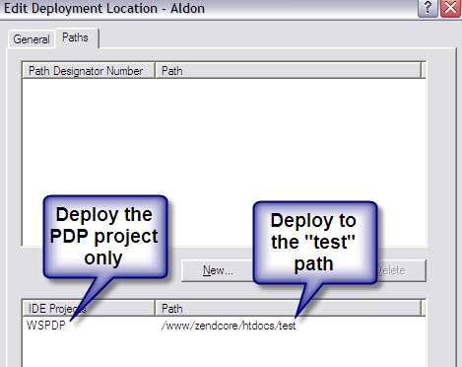

Deployment Mappings/General:
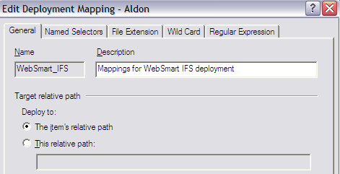

Deployment Mappings/File Extensions:
It is advisable configure the Deployment Profile to not deploy the PHW files. Remember that the PHW files are for development use only, they, themselves, do not drive the web application. Therefore, they are not needed on the production IFS directory. In fact, Aldon highly recommends that these objects be kept only in the LM inventory. This will ensure that all changes will be made only through the LM solution. To accomplish this, you will exclude parts with the “.PHW” extension from being deployed via the deployment profile’s mapping instructions.

